Business Applications

Activity Pitch Questionnaire (APQ)

ESA-TIAA-PO-2017-1054 - V.1.29
The present questionnaire intends to collect in a standardised way information on various aspects of your idea / proposition regarding the IoT device, in order to understand:
- what is the level of expertise / know-how of the proposer;
- what is the current level of maturity;
- what is the business target and business potential.

Please, keep your answers to a maximum limit of 10 pages, maintaining font size and structure.

Section AP.1: Background information

AP.1.1 Idea name: | Robotcar
AP.1.2 Team proposing:  (names and e-mail) | Sarmīte Endzele MT19001 sarmite.endzele@va.lv
AP.1.3 Does your team (company / consortium) have the right skills and experience to deliver what you are proposing?(Yes/No/Partial + comments. Please indicates which skills/expertise you possess/miss) |  | I think it is partial, because I do it first time and I have not experience. And would better programming skills.
Section AP.2: What do you want to offer and what is the added-value?

- What is the final service that you want to offer?
I would like create robot car with different sensors and possibilities.

- Who will be the customers/users of the final product / service?
(please note: users and customers can be different:
users will use the final product/ service but they do not necessarily pay for it;
customers will pay for the service, but they do not necessarily use it )
Just now it is for fun. But in next maybe its possibilities someone will need.

- What are the customers’/users’ pains (e.g. problems) and gains (e.g. benefits)? Can you quantify them?
(please note: whenever users and customers are different, pains and gains can be different as well)
recently saw a video where a remote delivery robot - a car - overturned on the curb of the sidewalk. maybe I would be able to create a better equipped robot that could read the dangers more successfully and make a better decision to overcome them.

Section AP.4: How do you intend to implement?

- What is the starting point before you start the activity you propose?
(e.g., idea, prototype, existing product, existing service, results from other activities, discussions with potential users)
unfinished prototype and my interest in how I wreak it and control it

- What are the key activities you propose to execute?
(e.g. commercial aspects: market analysis, winning over potential customers, business case investigation/definition, validation of business plan assumptions, preparation of service level agreement
e.g. technical aspects: proof of technical feasibility, proof of concept, design, development, integration, testing validation with pilot customers)

The main focus for our IoT&SN course is related to the technical aspects. Please include here: the system architecture (you have to provide a picture), detailed descriptions of the involved parts:
-what board/boards you use and why;
-what sensors;
-do you use Blink as mobile app?
-Do you consider using an IoT Cloud service?
You can take as an example these IoT specifications: https://moodle.va.lv/pluginfile.php/48337/mod_resource/content/2/IoTSN_Unit2.pdf -- system architecture, implementation details, schemes etc.
The system architecture can be drawn in draw.io or any other tool
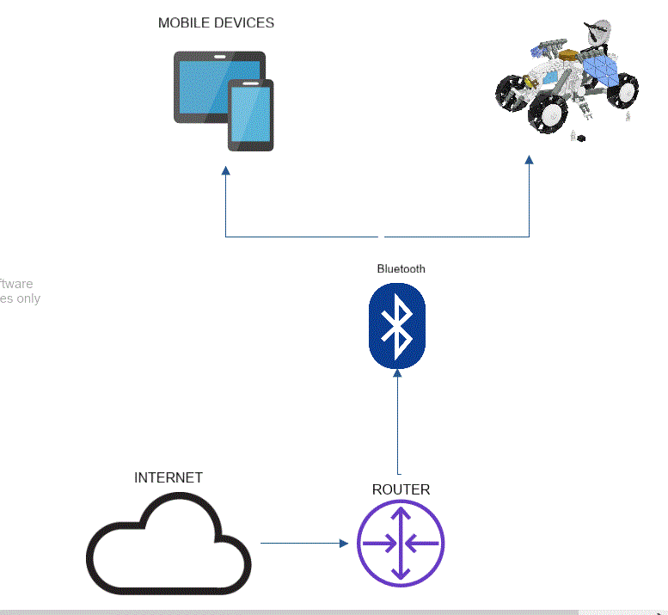
I choose Arduino Uno board, because it is available for me.
In this project I use Bluetooth sensor HM-10 and remote control L298N. In next there will be others sensors and camera.
I use mobile app creator MIT App Inventor.
Cloud I use in App Inventor, because it is cloud based tool.

- What are the most important risks (technical / business / commercial) to your activity? What are your mitigation plans?
Cyberattack, bugs, available of parts, war, economic crisis.
Different types of protection plans should be put in place.

